**Bookit Project**

**Bookit application description:**

Bookit is a web-based application. Bookit project is a meeting and conference scheduling software. This project is used in schools, and allow users(school staff and students) to schedule conference across the different location. 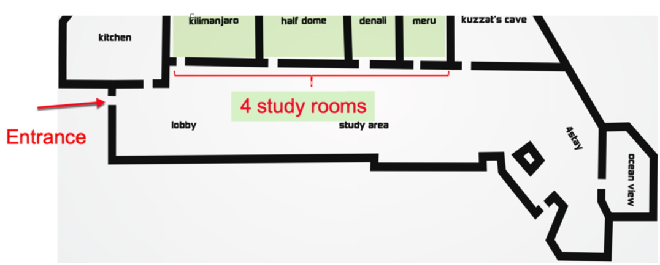

Bookit credentials: [EU-Bookit credential](https://docs.google.com/spreadsheets/d/1X7NHmrm-XaAaEnTBAFiXBlomAYigyZHzzHtm909_WUs/edit?usp=sharing)

User Stories & Test Cases: [EU_BOOKIT stories&TCs](https://docs.google.com/spreadsheets/d/1aLcA1--Hagk7prjz51HdJ9D6sCXMXN4R9mv4LCtRLKg/edit?usp=sharing)